**DISTRIBUTION OF ELECTRICITY**

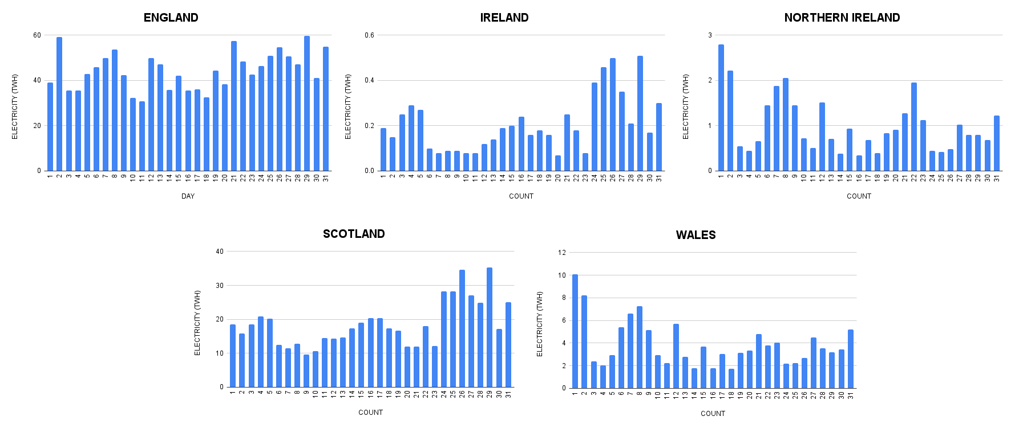

The Average Electricity Distributed to England, Ireland, Northern Ireland, Scotland, and Wales was 44.6 TWH, 0.2 TWH, 1.0 TWH, 18.7 TWH, and 3.9 TWH.

**DECARBONIZATION STRATEGY**

**FOR NATURAL GAS:**

**England:**

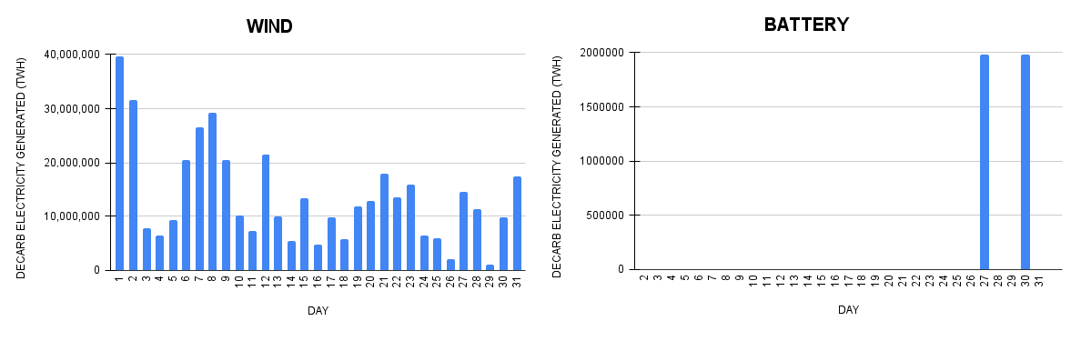

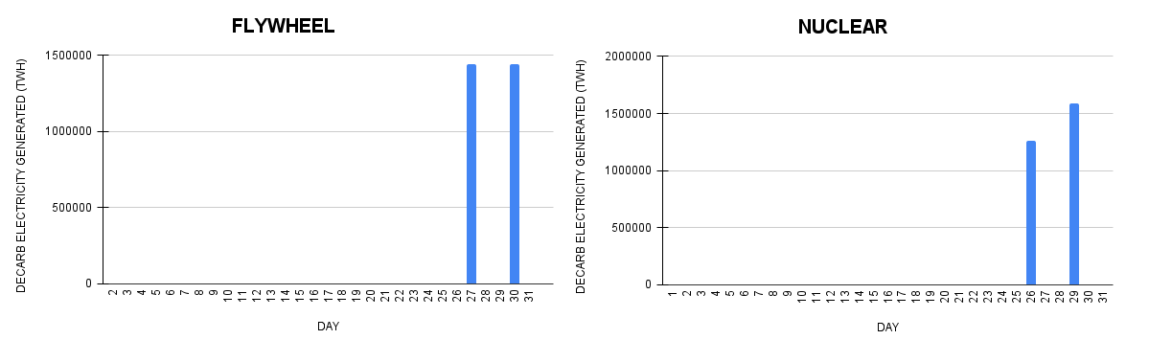

**Northern Ireland:**

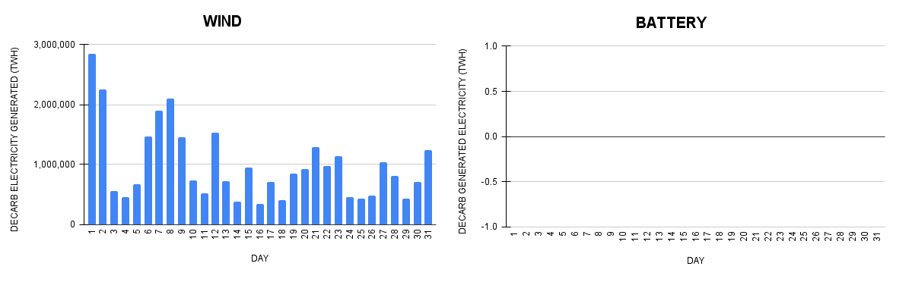

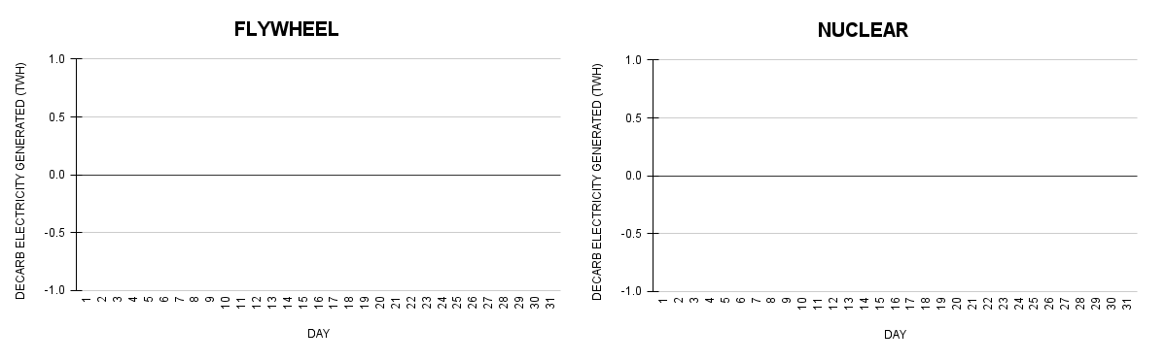

**Scotland:**

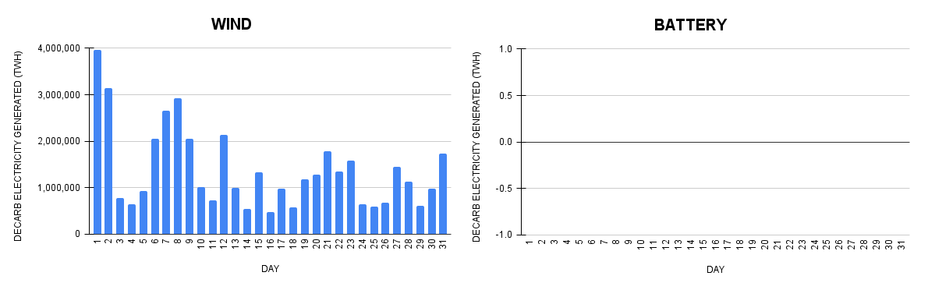

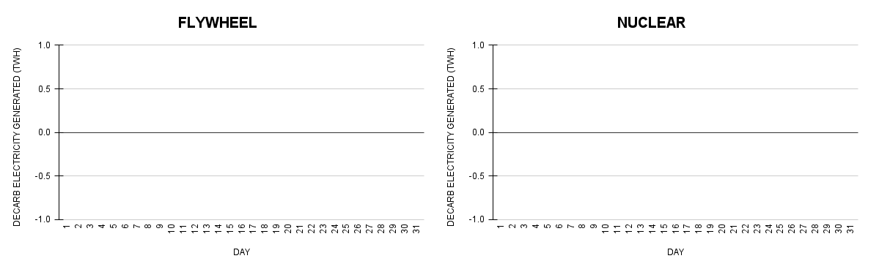

**Wales:**

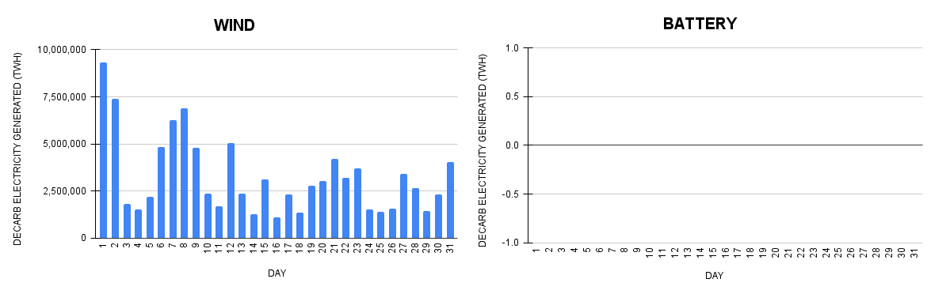

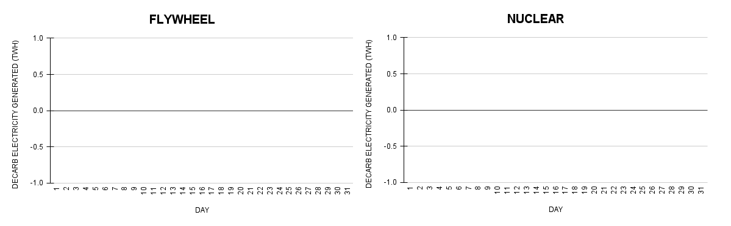

Wind, Battery, FlyWheel and Nuclear Power Plants Could have Produced 13,558,223 TWH, 127,742 TWH, 92,903 TWH, and 91,678 TWH of Zero-Emission Electricity in England this month.

Wind Power Plants Could have Produced 995 TWH of Zero-Emission Electricity in Northern Ireland this month.

Wind Power Plants Could have Produced 1,385,105 TWH of Zero-Emission Electricity in Scotland this month.

Wind Power Plants Could have Produced 3,256,362 TWH of Zero-Emission Electricity in Wales this month.

**FOR BIOMASS**

**England:**

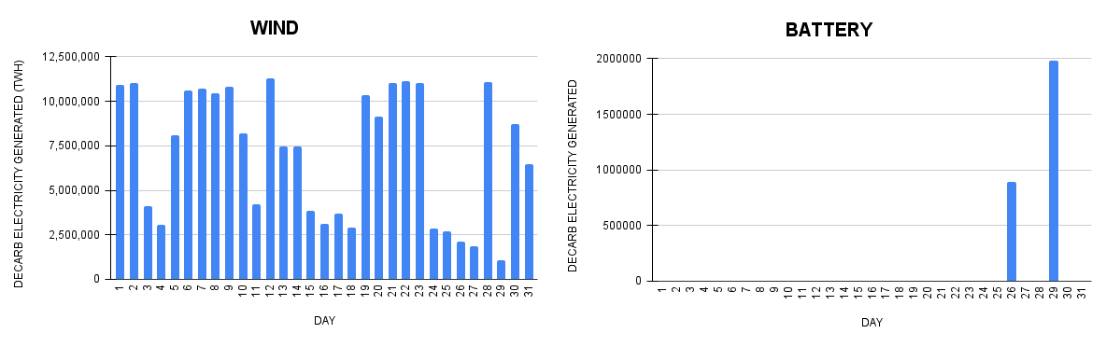

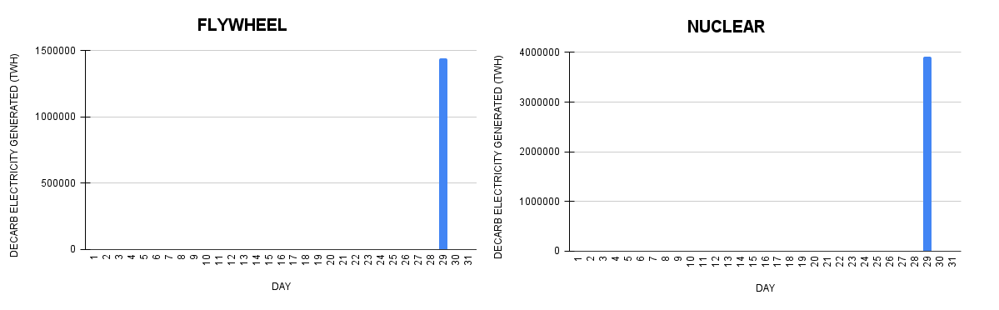

Wind, Battery, FlyWheel and Nuclear Power Plants Could have Produced 7,149,368 TWH, 92,671 TWH, 46,452 TWH, and 126,348 TWH of Zero-Emission Electricity in England this month.

**DECARBONIZATION REALIZABLE**

England - 4,400,592,886 (kg CO2e)

Ireland - 0 kg CO2e

Northern Ireland 206,021,050 (kg CO2e)

Scotland - 284,966,822(kg CO2e)

Wales - 674,617,949 (kg CO2e)

**ELECTRICITY COST**

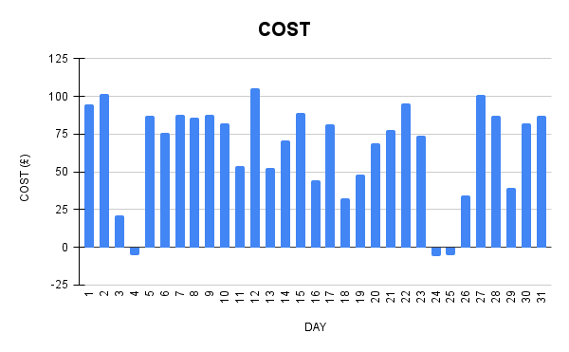

Cost of Electricity Ranged from -£5.97 to £105.62.

**IMPORT AND EXPORT**

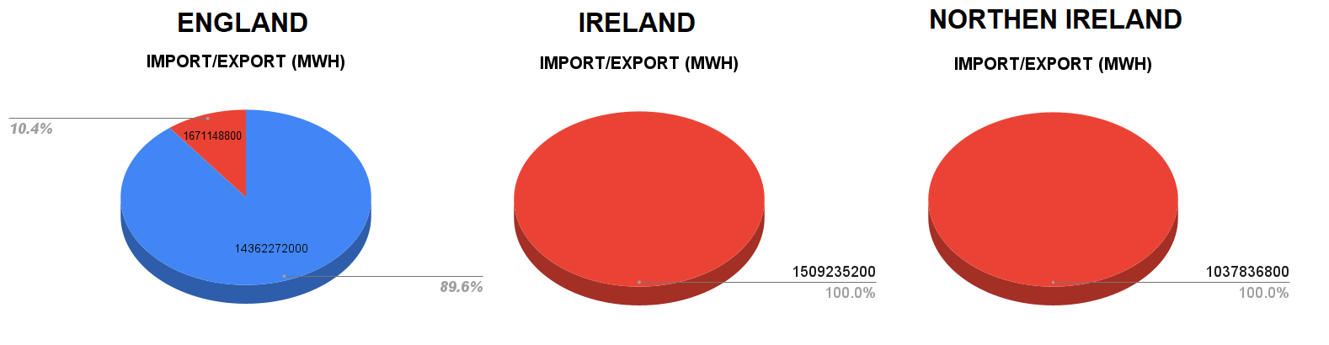

England Imported 14,362,272,000 MWH and Exported 1,671,148,800 MWH. Ireland Exported 1,509,235,200 MWH. Northern Ireland Exported 1,037,836,800 MWH.

**ELECTRICITY FORECAST**

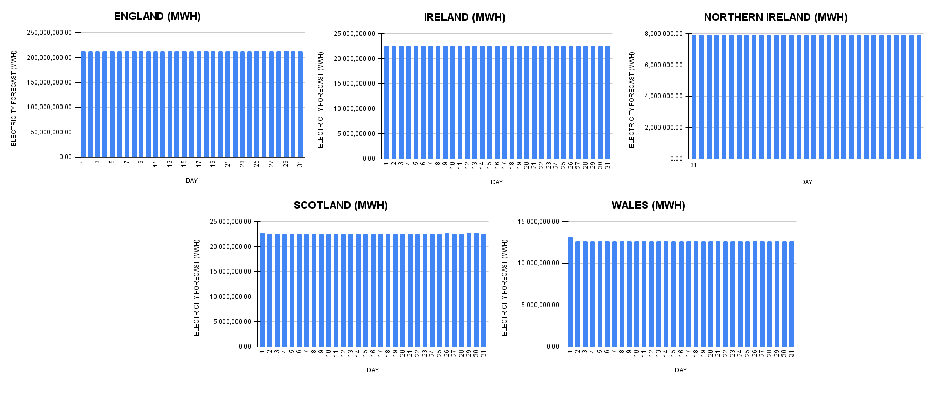The Average Electricity Forecast for England is 212,681,631 MW. The Average Electricity Forecast for Ireland is 22,575,591 MW. The Average Electricity Forecast for Northern Ireland is 7,918,023 MW. The Average Electricity Forecast for Scotland is 22,611,707 MW. The Average Electricity Forecast for Wales is 12,673,673 MW.

**POWER GENERATION ACROSS THE UNITED KINGDOM:**

28% from Natural Gas, 38% from Wind, 23% from Nuclear, 10% from Biomass, and 1% from Hydro**.**